## Data gathering and requirements

1. Persona 1

** NOT MENTIONED **

|  |  |
| --- | --- |
| Persona: | InteriAR user persona |
| Photo: | https://www.womenshealth.gov/files/images/nwhw_30s-lady.jpg |
| Name: | Emily Campbell |
| Job title/major responsibilities: | Part time office administrator; temporarily quit full time work to care for her children. |
| Demographics: | * 31 years old * In a long term relationship * Physically able * Speaks English * Mother of 2 young children |
| Goals and tasks: | She is family oriented and takes great pride in her home, always looking to keep things fashionable and looking good.  One day she’d love to design her own home from scratch but isn’t yet in the financial position to do so.  Her daily tasks consist of caring for her children as well as part-time database upkeep in an insurance company. |
| Environment: | Emily owns a smart phone, current gen tablet and a family laptop. She considers herself relatively capable of using them all although she couldn’t tell you what SSD stands for or how much RAM she’s got.  She regularly browses the internet (connected via fibre home-broadband) and uses apps on her devices for both her and her children. |
| Quote: | “I know what I like, and how I like it.” |

1. Persona 2

** NOT MENTIONED **

|  |  |
| --- | --- |
| Persona: | InteriAR user persona |
| Photo: | https://edc2.healthtap.com/ht-staging/user_answer/reference_image/6096/large/Testicular_Cancer.jpeg?1386670792 |
| Fictional name: | Dave Taylor |
| Job title/major responsibilities: | Full time newspaper columnist. |
| Demographics: | * 35 years old * Single * Requires a wheel-chair * Speaks English * No children |
| Goals and tasks: | Having recently bought his own flat for the first time, though it only has a couple of rooms he wants to make it really his. While he isn’t one for elaborate or fancy designs, he wants control of every detail and needs to know how it’ll look before committing.  His daily tasks are primarily writing and researching, both from the office and at home. |
| Environment: | Dave owns a large Note smartphone, no tablet and utilises a work laptop for several hours a day. He considers himself intermediate to advanced internet user and has broadband at home. |
| Quote: | “It’s my way or the highway.” |

1. Persona 3

** NOT MENTIONED **

|  |  |
| --- | --- |
| Persona: | InteriAR decorator persona |
| Photo: | http://www.absolutedecorating.com/wp-content/uploads/2016/01/professional-painter-and-decorator.jpg |
| Name: | Jeremy Trotter |
| Job title/major responsibilities: | Full time painter-decorator; team manager on larger projects. |
| Demographics: | * 42 years old * Married * Speaks English * Father of 2 teenage children * Physically active and able * Level 3 City & Guilds in painting and decorating * CHAS certified |
| Goals and tasks: | He loves his job and is adamant about maintaining a high quality finish in all his work. His goal is to help people bring their creative ideas and designs to life with his technical ability.  He spends time at work primarily out of office; painting and decorating, project managing, and training less senior decorators. |
| Environment: | Jeremy has a smartphone he’s competent with and is confident on the computers at the company office. He has a business line internet connection at work and ADSL-broadband at home. He primarily uses e-mail and SMS for communication. |
| Quote: | “If you want something done right, I’m your man. No job too big or small.” |

1. Stakeholder Diagram

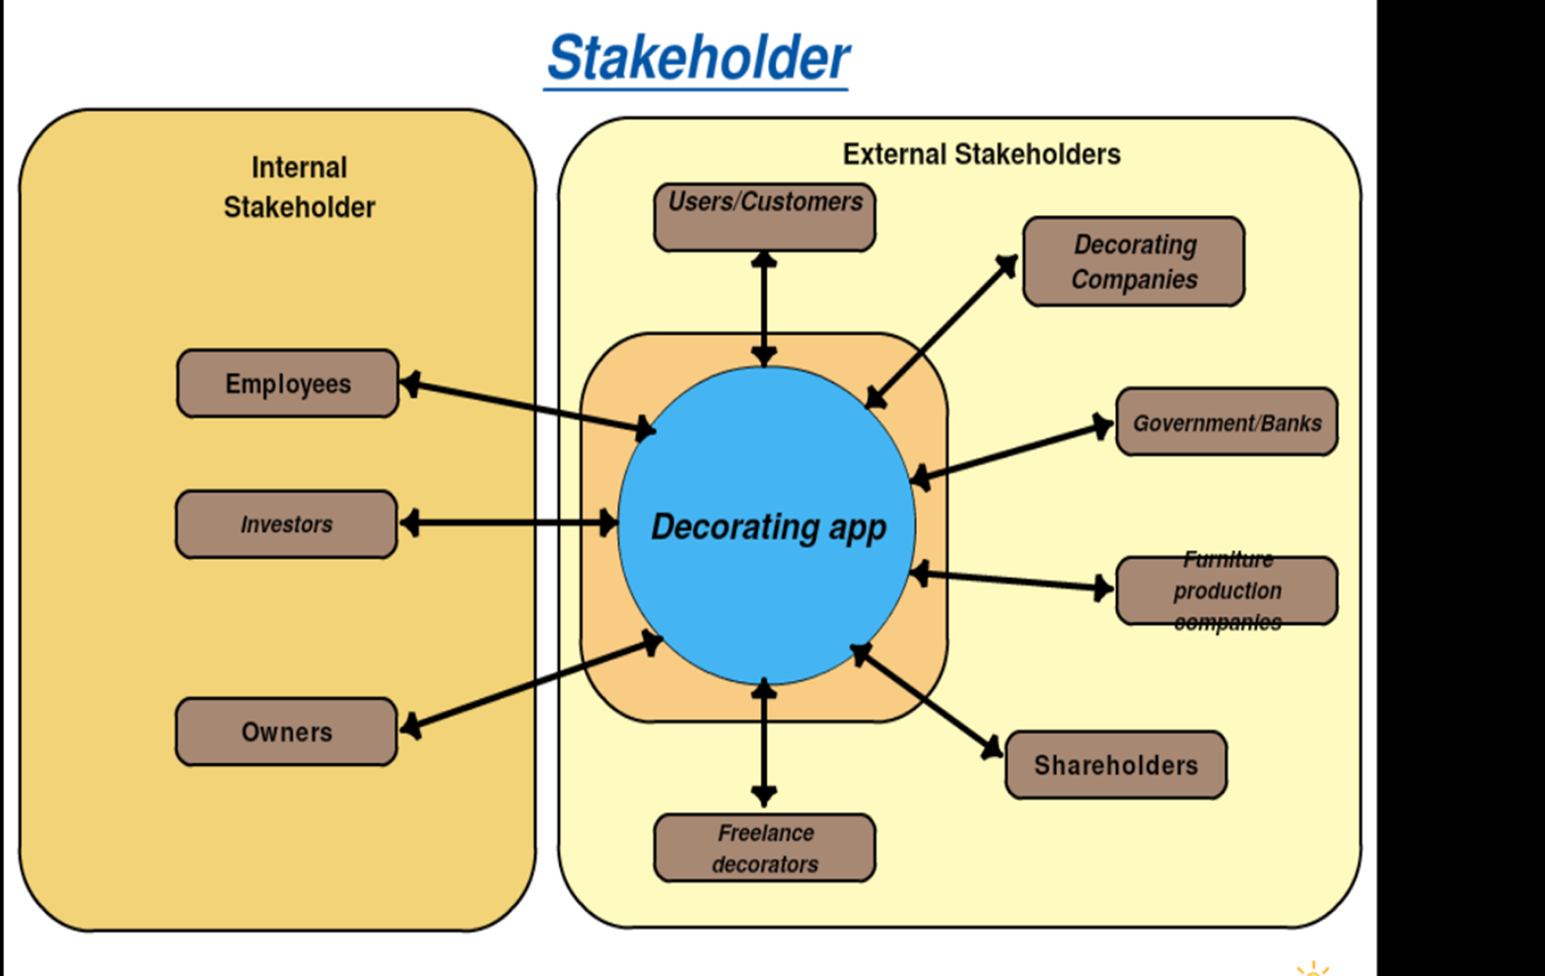

1. Accurately projecting 3D objects into an augmented reality space.

The issue in projecting objects into reality is firstly how to display the object. Augmented reality uses overlapping techniques to give the illusion that something virtual is occupying a real space. This starts off as images being placed over a live camera feed, however this ruins the illusion as small movements quickly reveal the fact that it’s just an image and nothing more. To get around this, several techniques are implemented to continue the illusion such as overlaying the camera with a virtual space, so when you place the object, you actually place it in a 3D space, which you can move around. This allows you to be able to correctly capture camera angles of a 3D object. This virtual space will attempt to match the angle and depth of your reality.

We explored several types of AR, and boiled it down to two. Projection based [REF] and Recognition Based[REF].

1. Coding the ability to virtually paint walls which will include image segmentation, colour distance calculating and more.

As this is an uncommon computation problem, there aren’t many code extracts we could use to aid us. However, we have managed to gather a lot of the computer vision topics we would need to be able to colour walls in virtually. Firstly, we would have to find a way to separate what is ‘wall’ and what isn’t. For this we would need image segmentation, a way of segmenting an image into like categories. From this, we can identify everything that’s similar, and apply an overlay where necessary. In this case, it would be a selected colour.  We could calculate colour distance  to also pick out specific colours in the camera at one time and change or overlap them with another colour. The problem as per our functional prototype, is that there are a lot of similar colours with an image, and colours constantly change throughout a camera’s feed. This causes the colouration to change as well as not cover the area correctly.

## Functional Specification

1. Functional Architecture Diagram

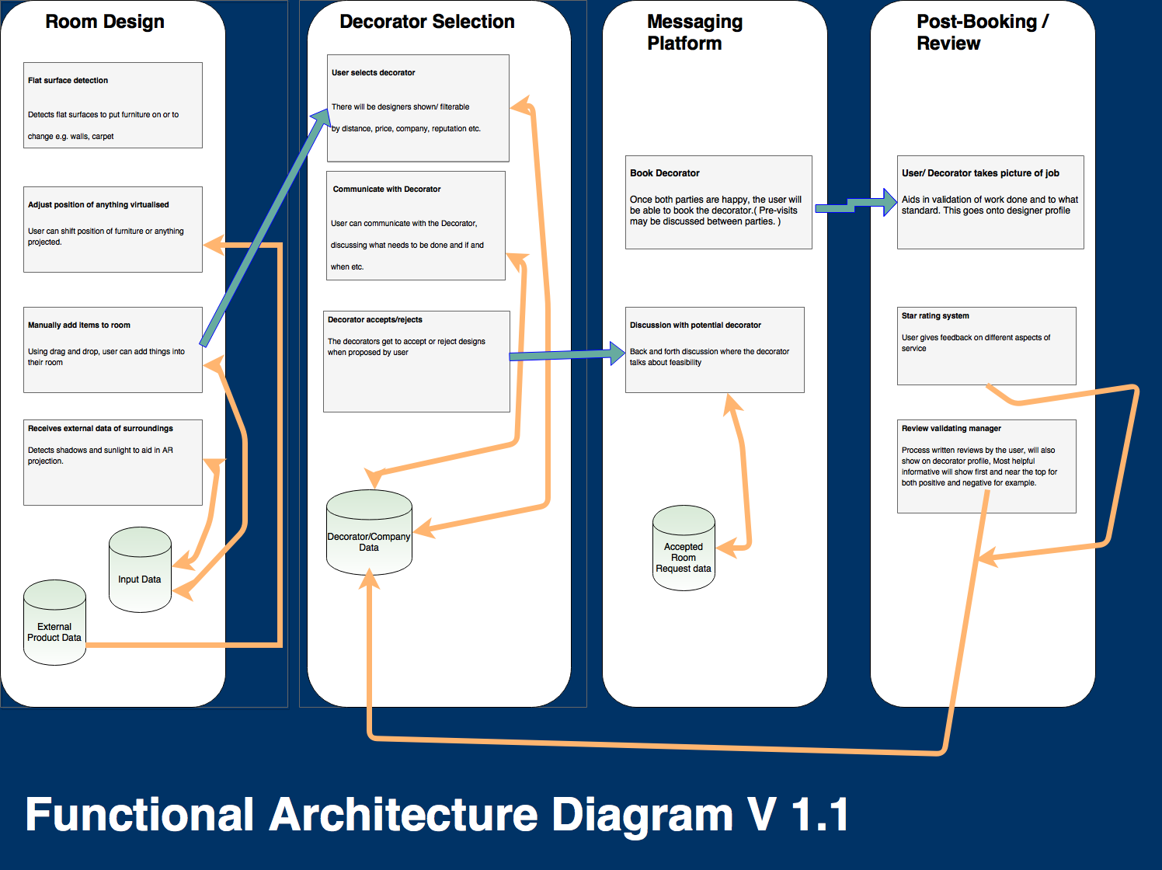

## Design

1. Sequence Diagram
2. Use Case Diagram**NOT MENTIONED**
3. Activity Diagram
4. Statements of Interest?????

## Prototyping

1. Images of Conceptual Prototype
2. Survey V2 images
3. Similar software researched

Dulux visualizer – an app distributed by Dulux which allows users to virtually test out their range of paint by applying it to their walls in an augmented reality environment.

The core functionality is strong; if we could manage similar results with some minor tweaks it would be ideal.

Drawbacks:

* Inability to paint connecting walls separate colours.
* No differentiation between ceiling and walls.
* Objects too similar in colour to the walls get misinterpreted as being part of the wall and change colour along with it.

Thoughts on their implementation:

* The software must utilise colour detection and then recolour anything within a certain “colour distance” to match the desired colour. This leads to both drawbacks, but allows for a very intuitive user-experience of simply tapping where you want to paint and it filling in the rest.
* While the errors in detection are frustrating, when working it manages to look very smooth. I believe it isn’t going through pixel by pixel and recolouring each one.

## Project management

1. Gantt Chart
2. Critical Path